I have created separate pipelines for the dev and prod environments. Whenever a developer pushes code to the Git repository, the project is automatically built and deployed to the Docker repository. I have attached a screenshot for reference

**Git hub Url :** [**https://github.com/Sivarepo24/project1**](https://github.com/Sivarepo24/project1)

**Docker dev Image : docker pull sivakumar135/guvi_project_dev**

**Docker prod Image : docker pull sivakumar135/guvi_project_prod**

**Deploy site url :** [**http://65.0.138.58**](http://65.0.138.58)

**Ec2 Instance**

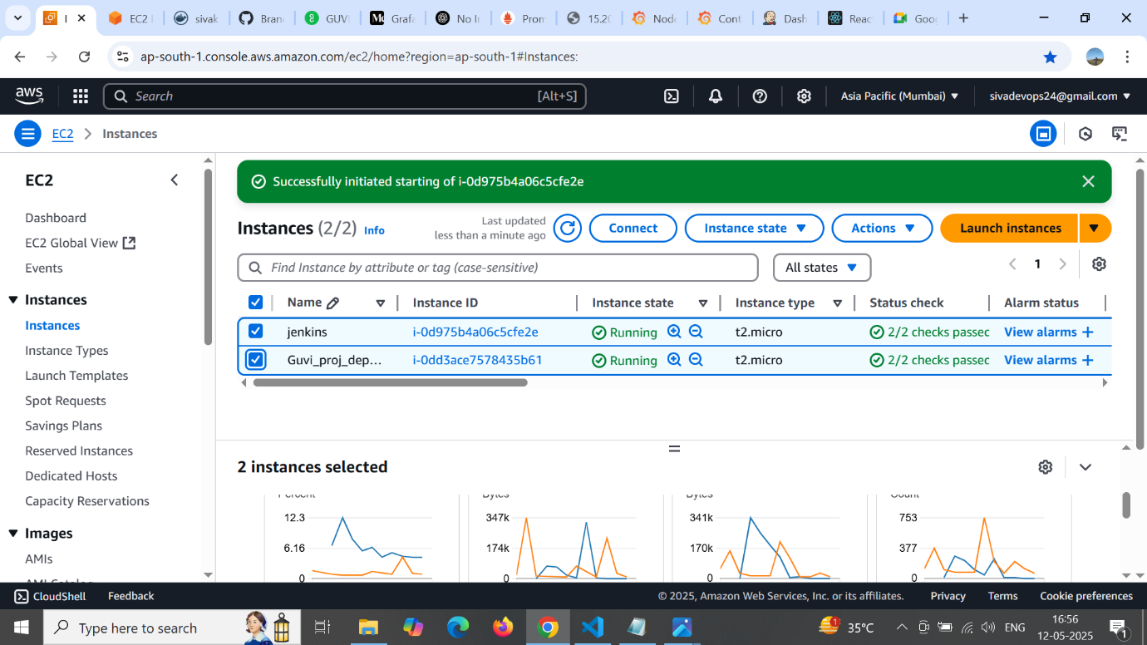

**Pull image to docker repo**

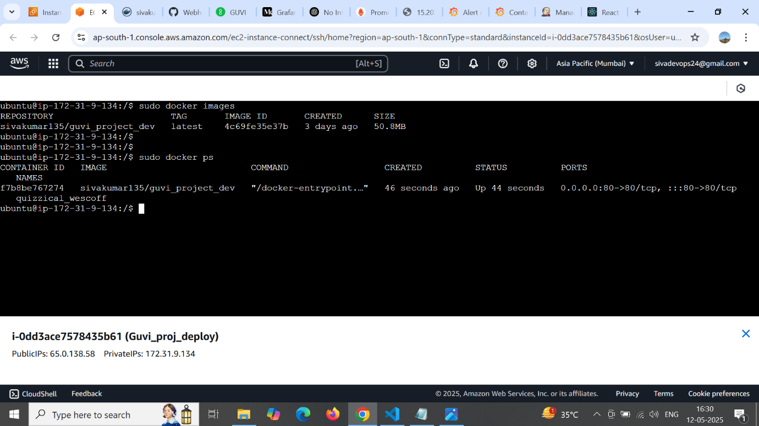

**Output**



**SG – Guvi_proj_deploy**

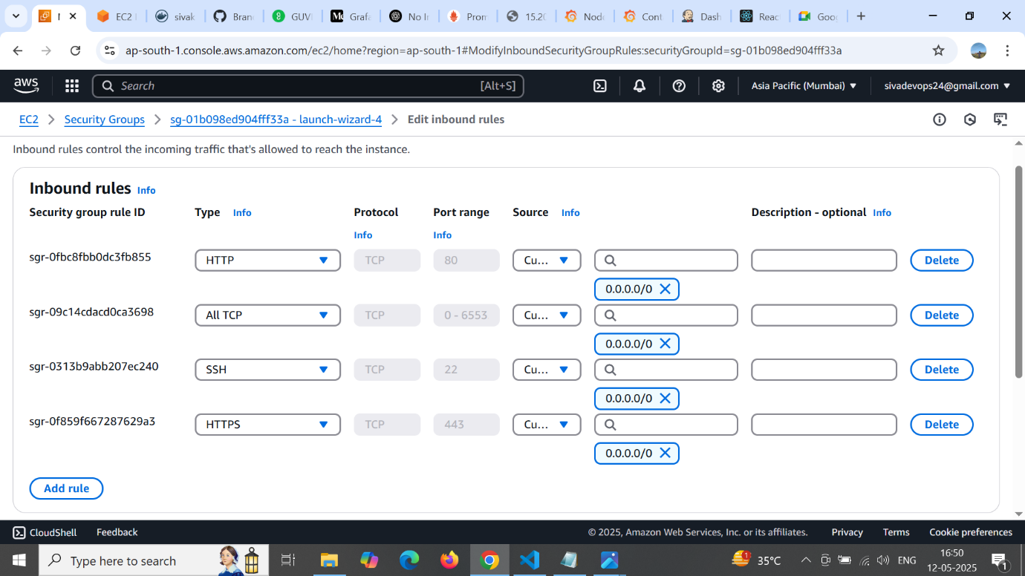

**Jenkins instance security Group**

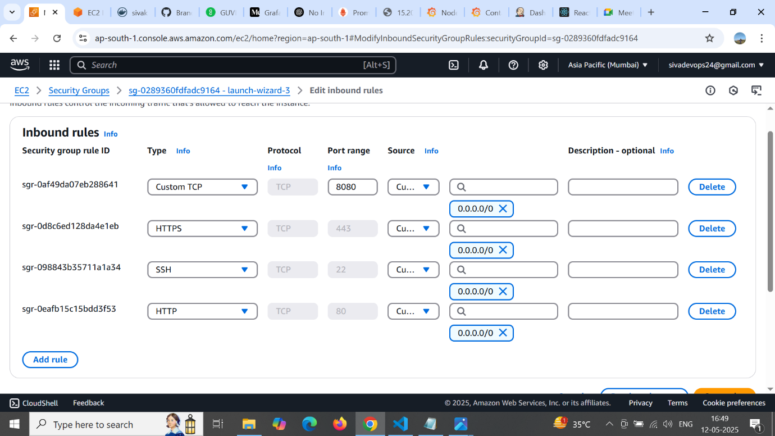

**Jenkins**

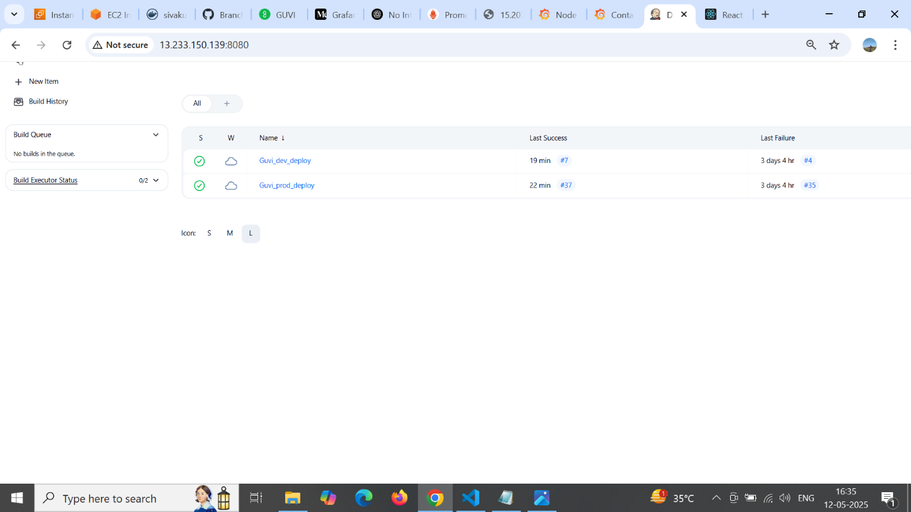

**Jenkins Configure (main-branch)**

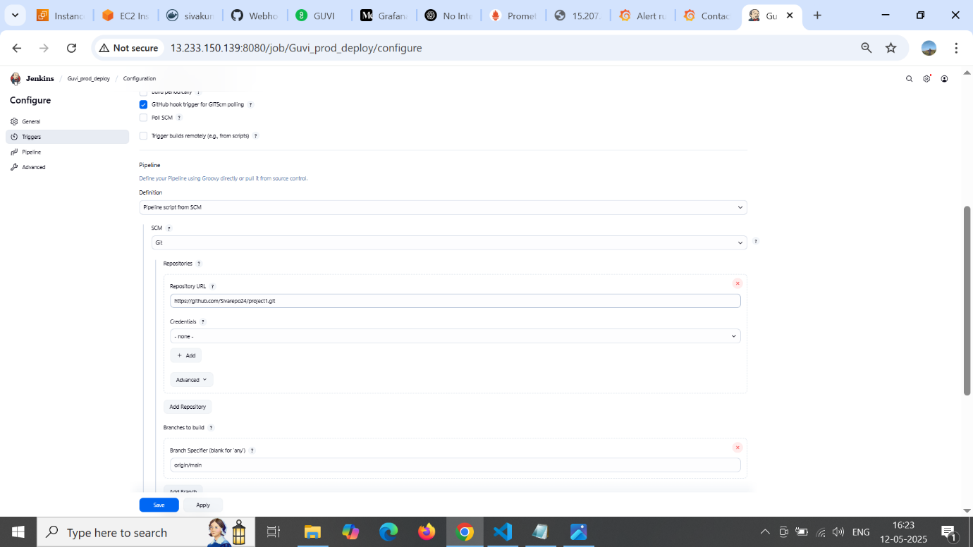

**Jenkins configure (stage-dev) branch**

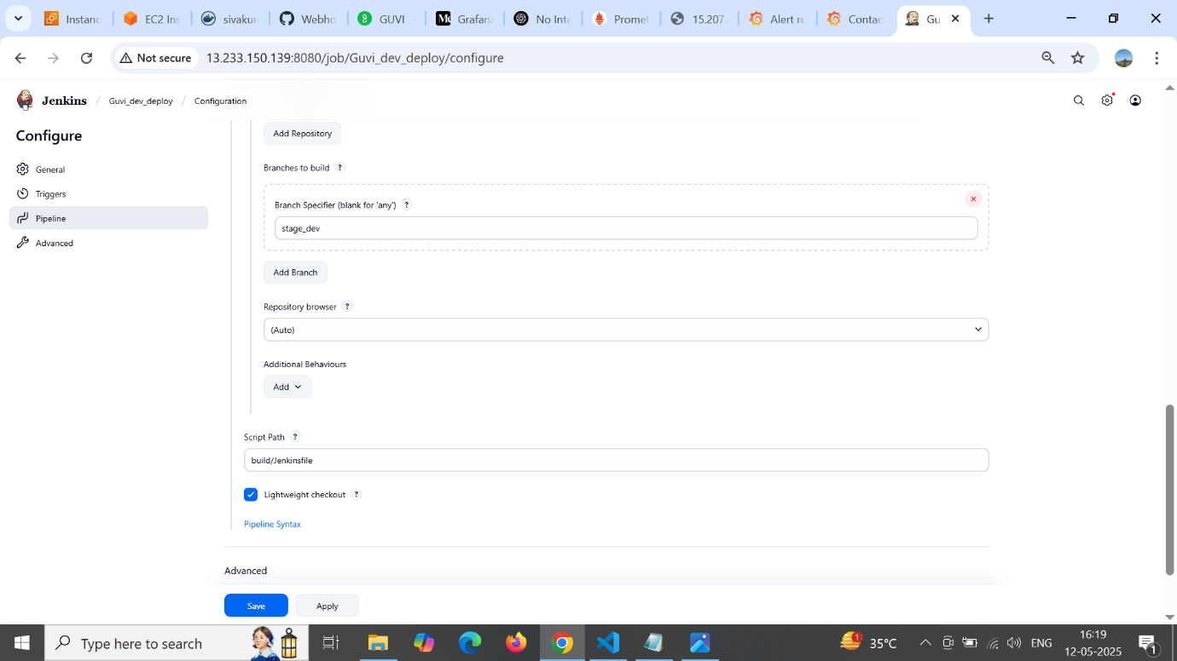

**GitHub webhook**

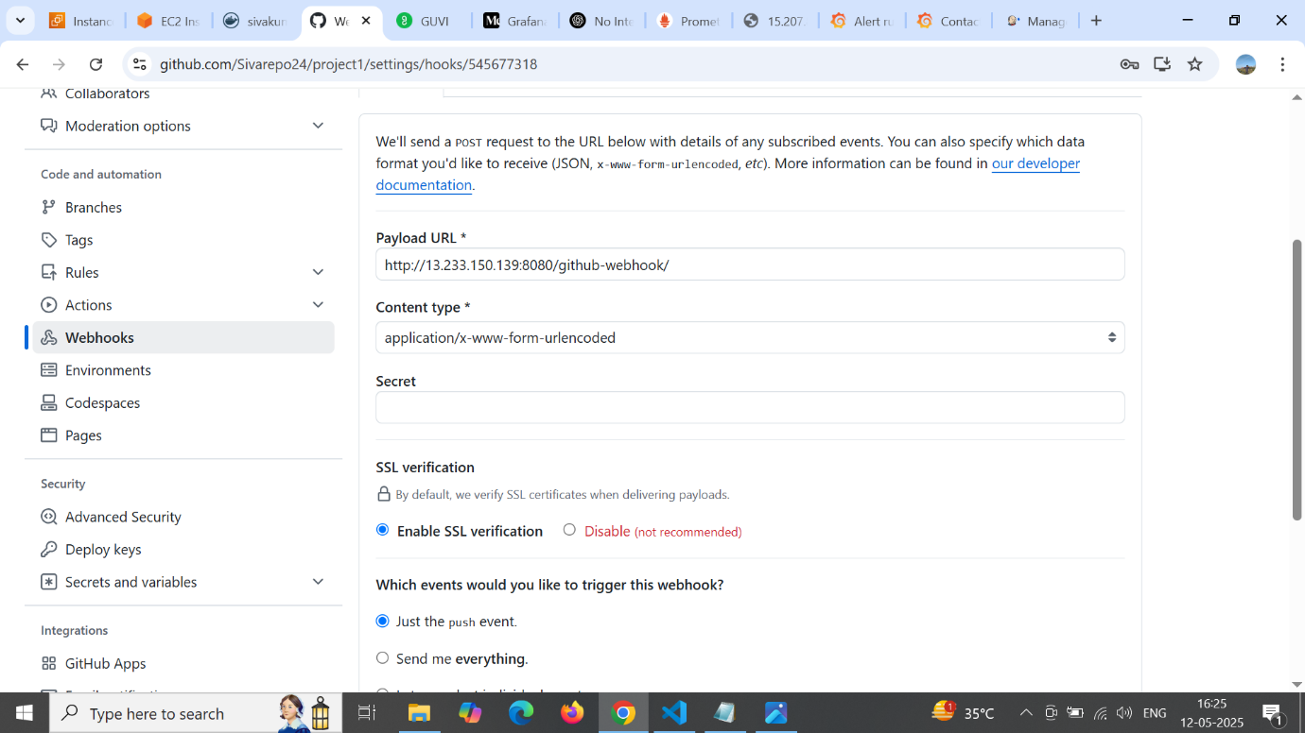

**Jenkins: GitHub configure**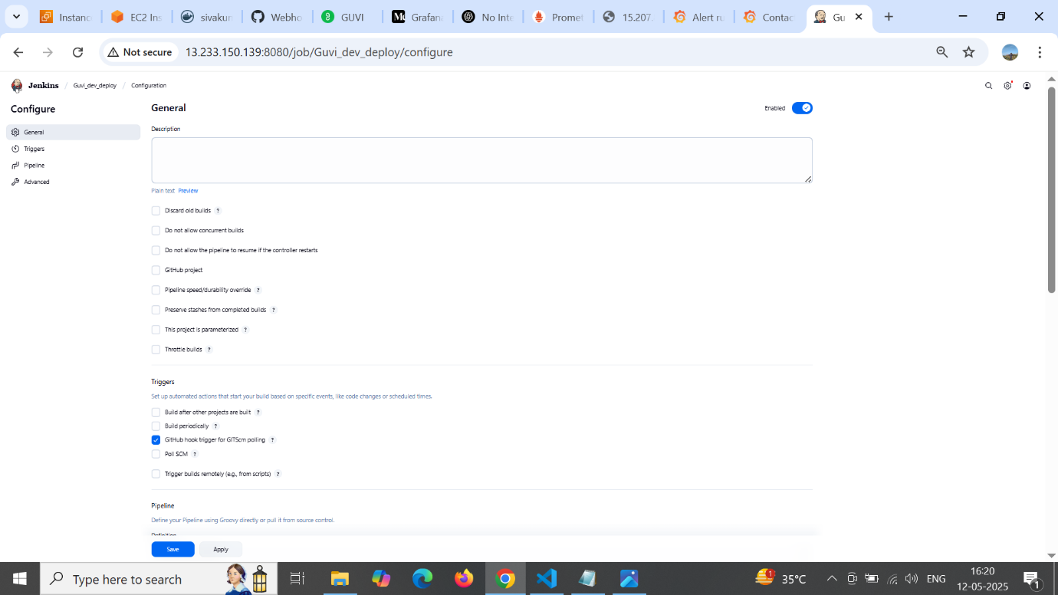

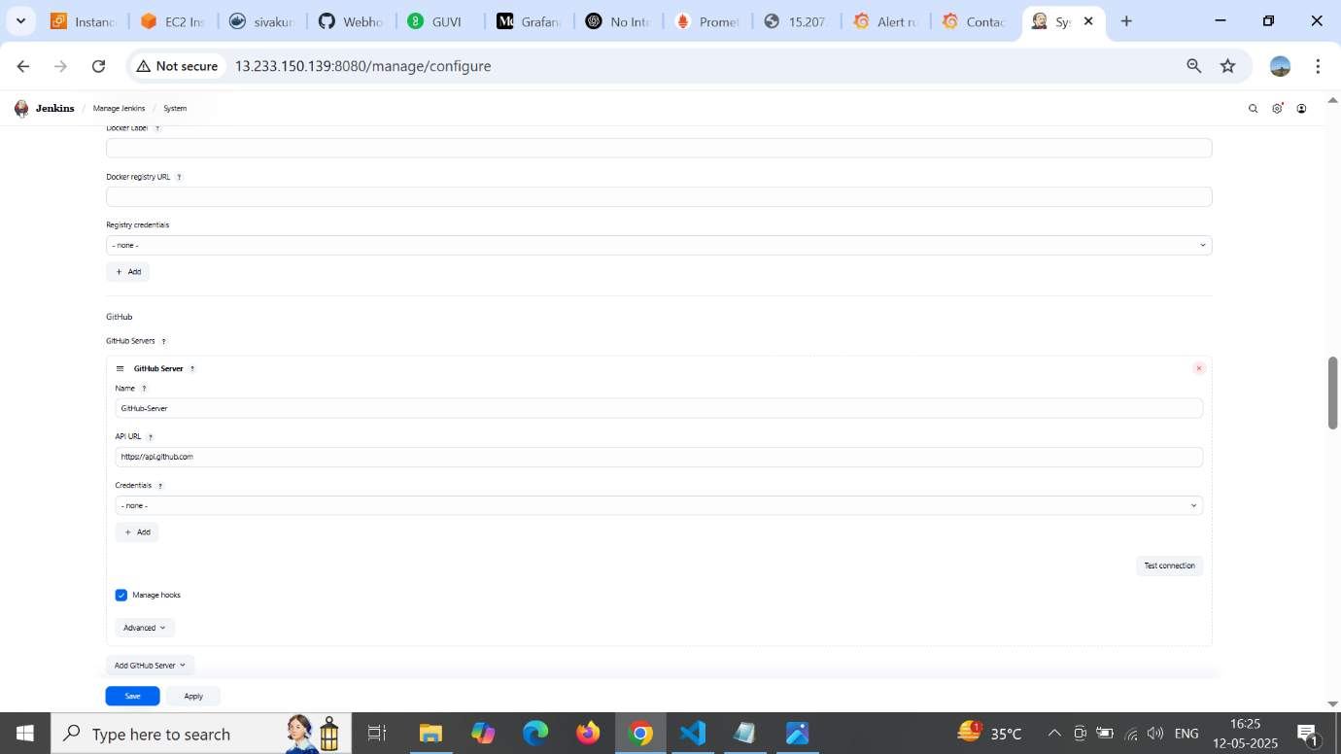

**GitHub Branches**

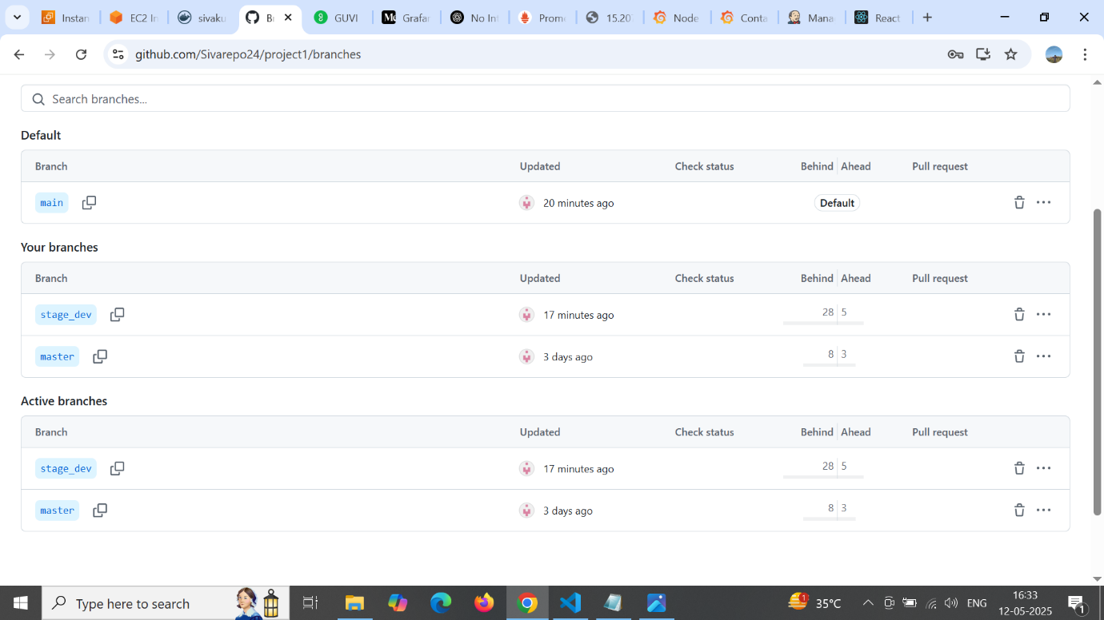

**Docker Repo**

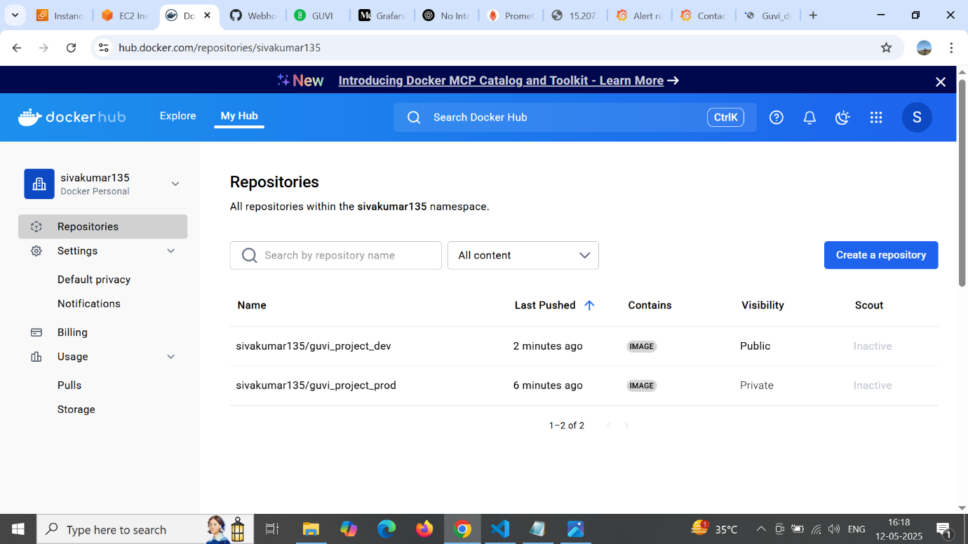

**Docker: project prod**

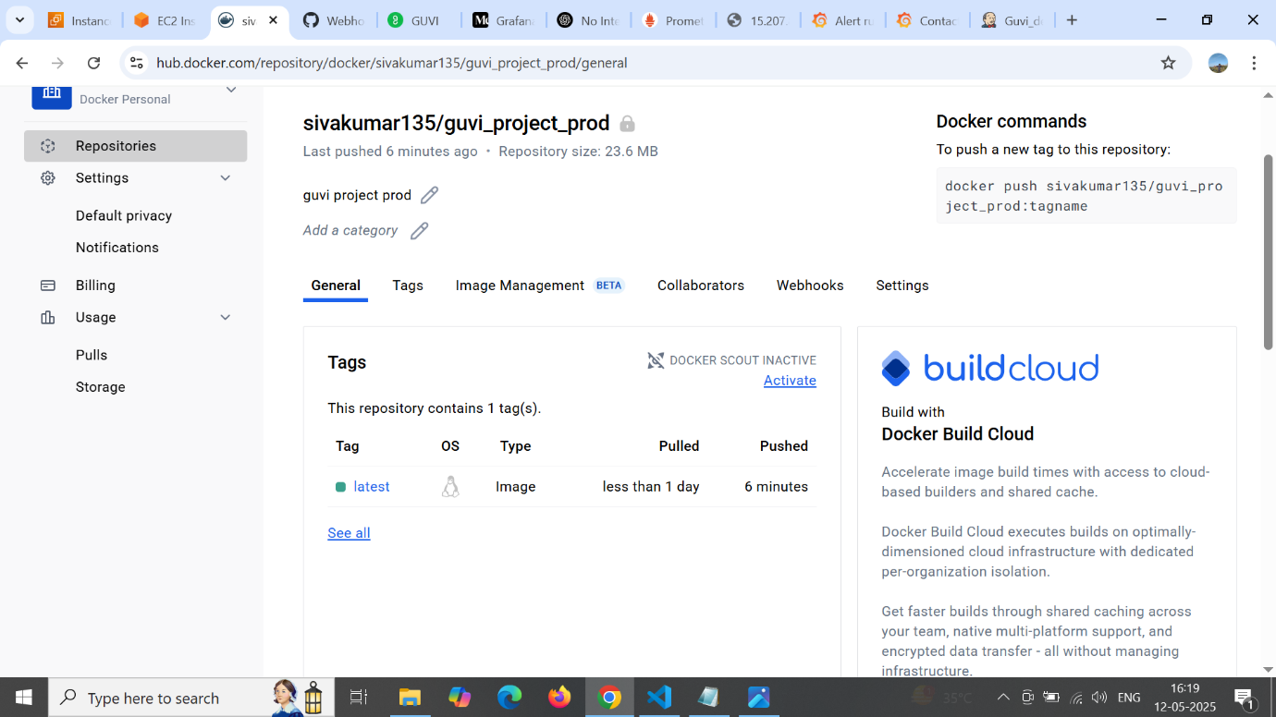

**Docker : project dev**

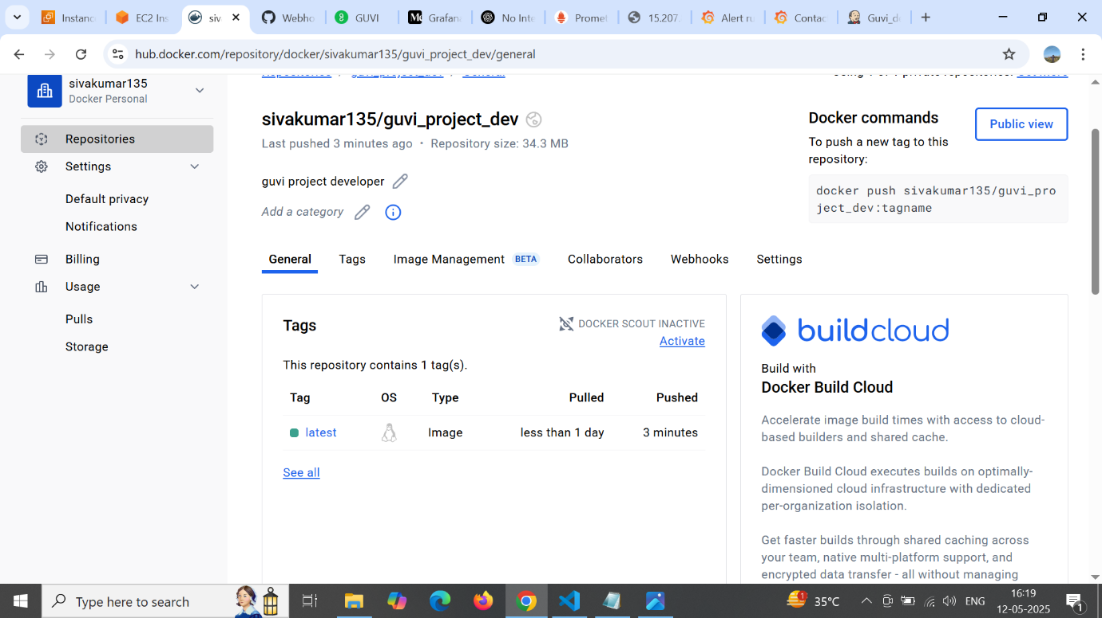

**Grafana: Alerting Rule**

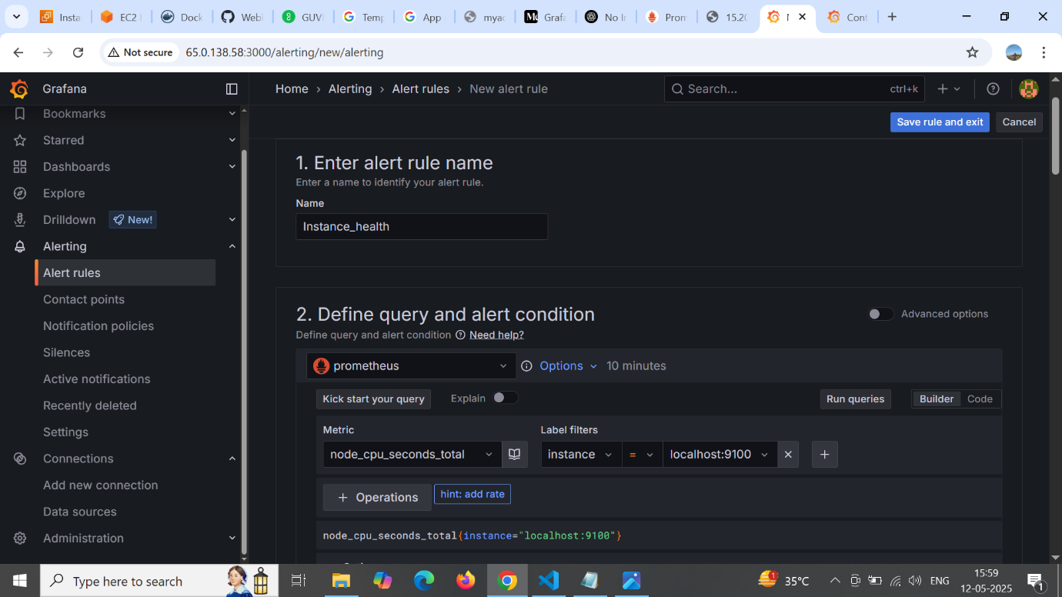

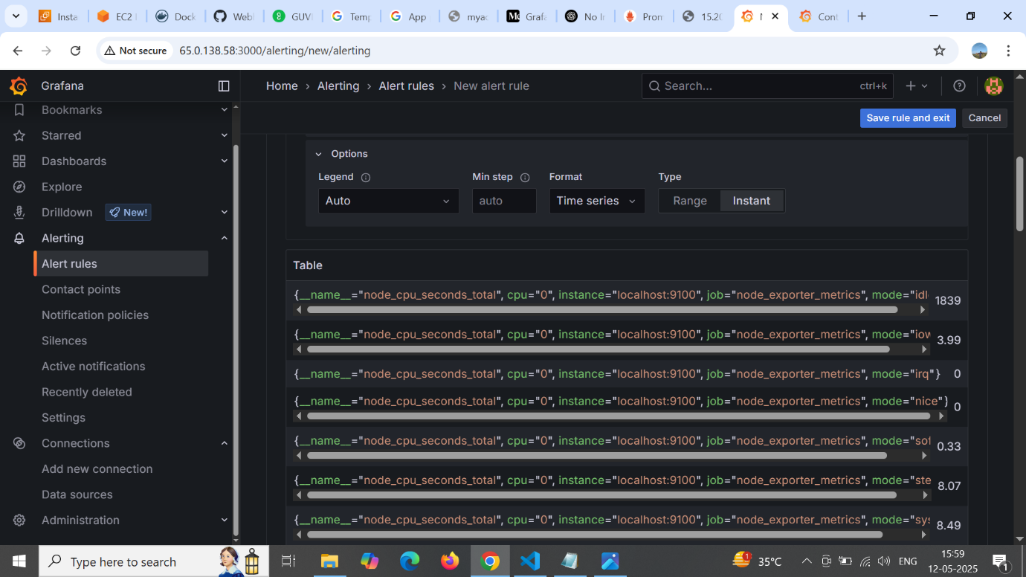

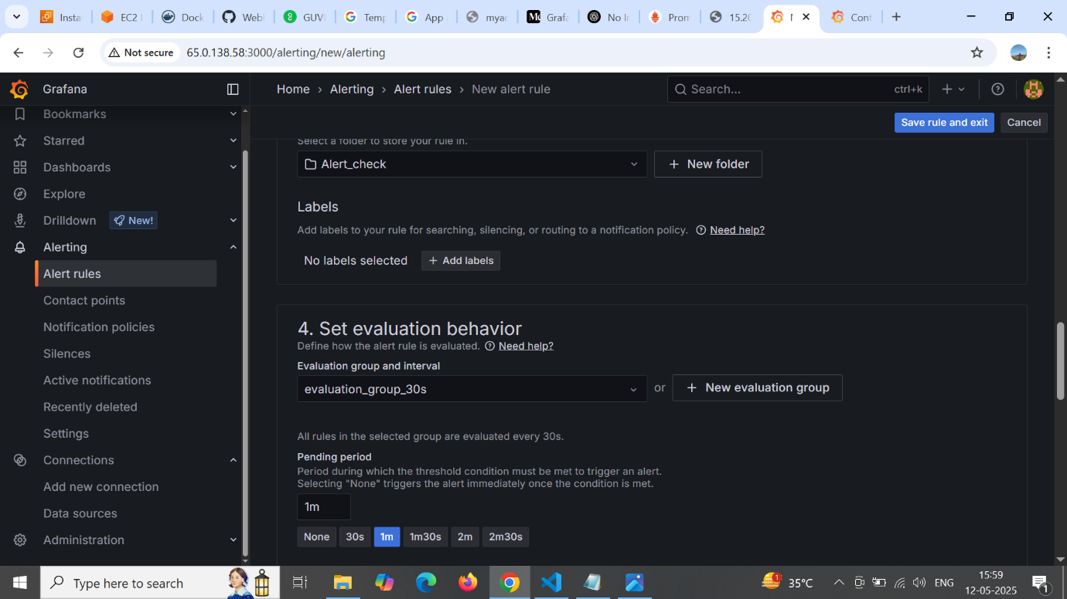

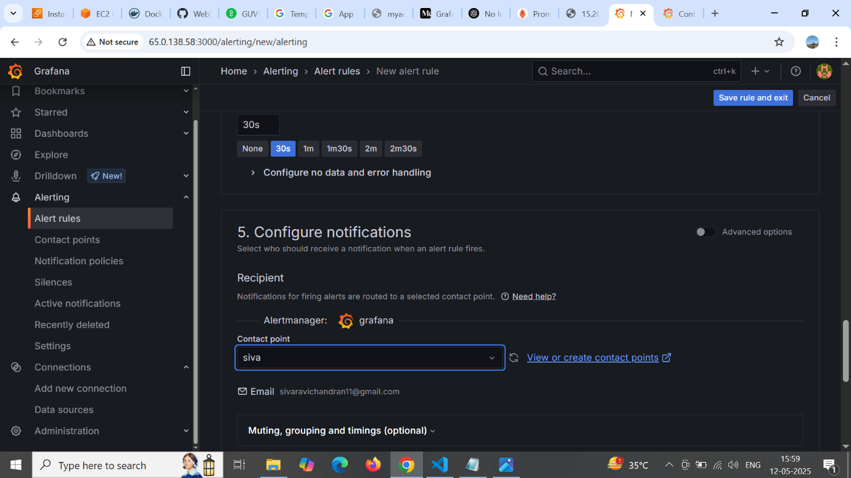

**SMTP configure in instance**

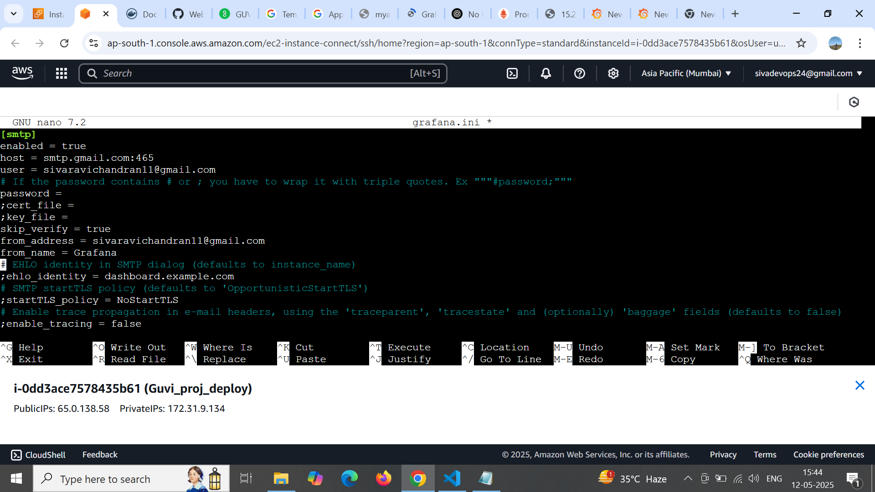

**Grafana contact point**

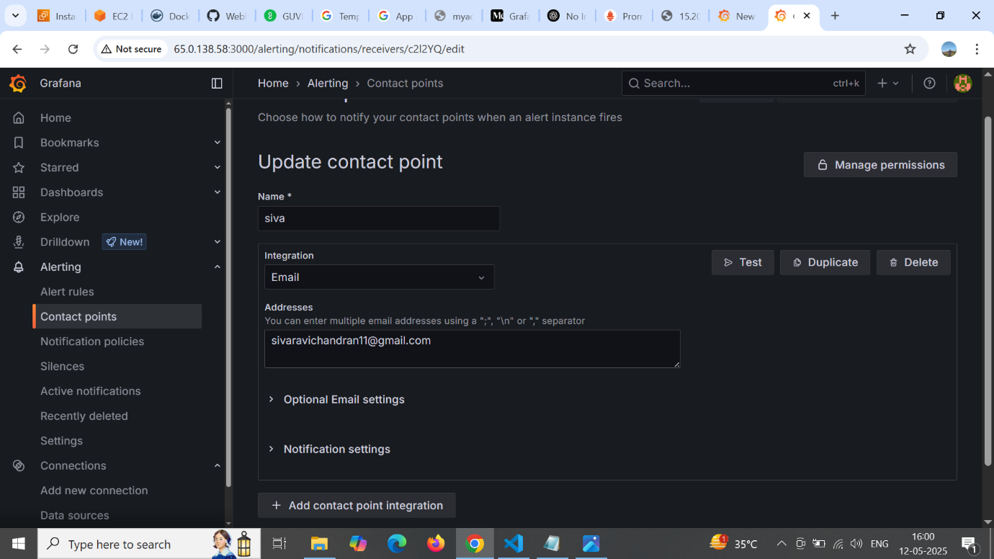

**Grafana Alert E-mail**

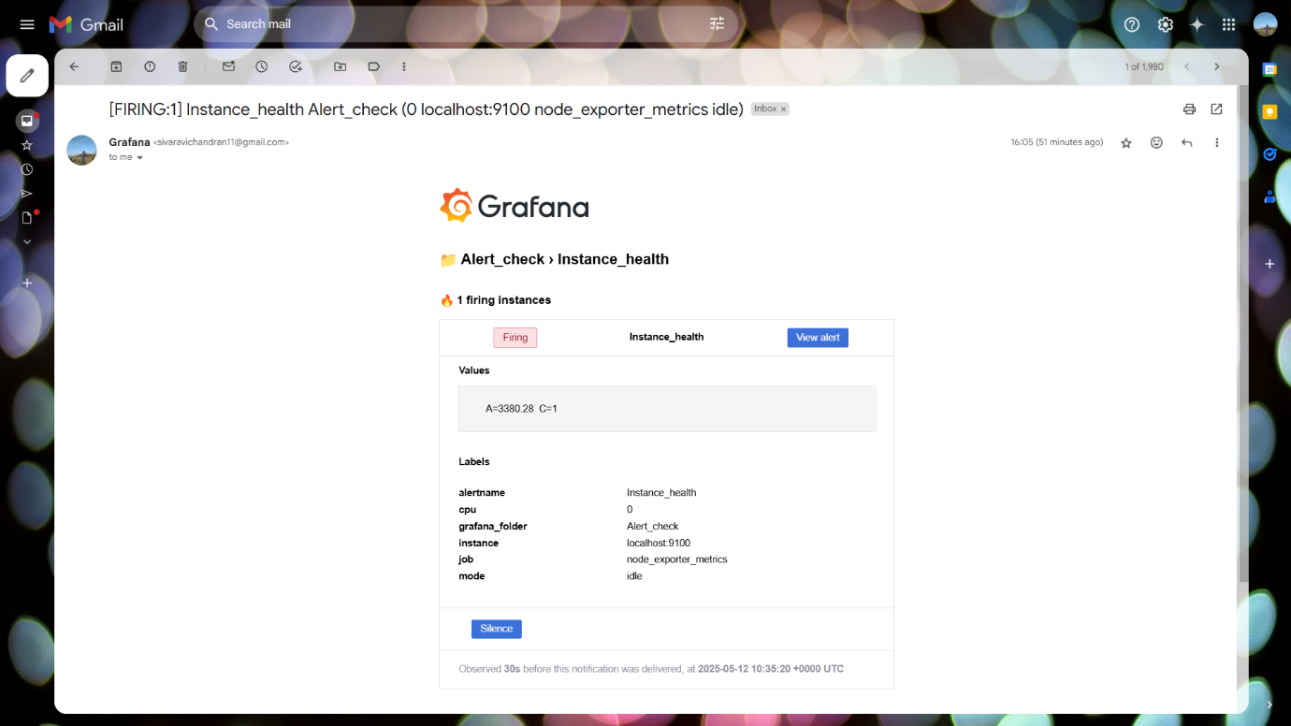

**Grafana Dashboard**

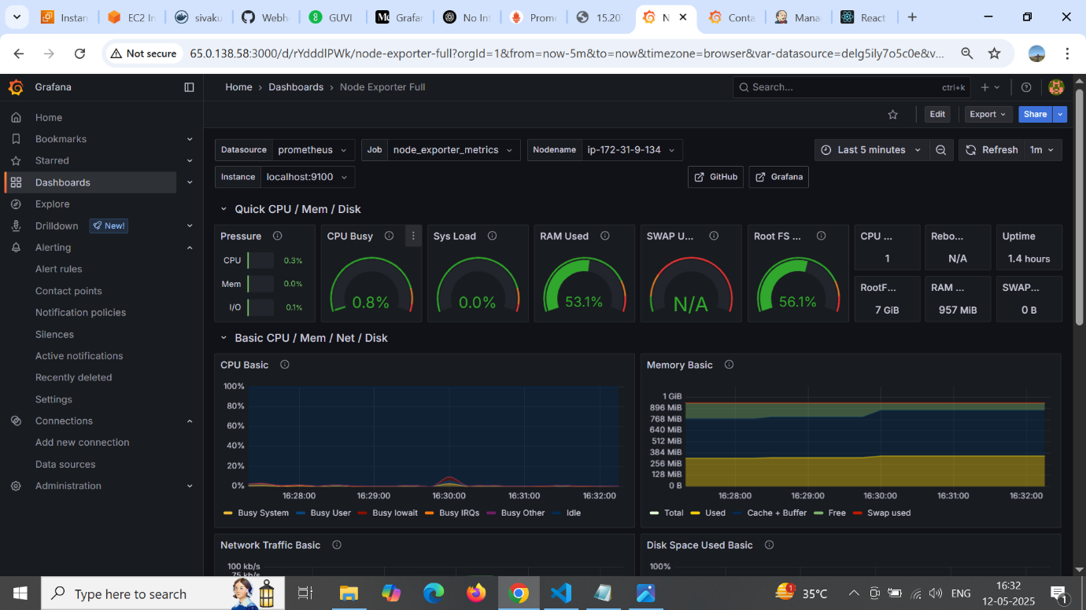

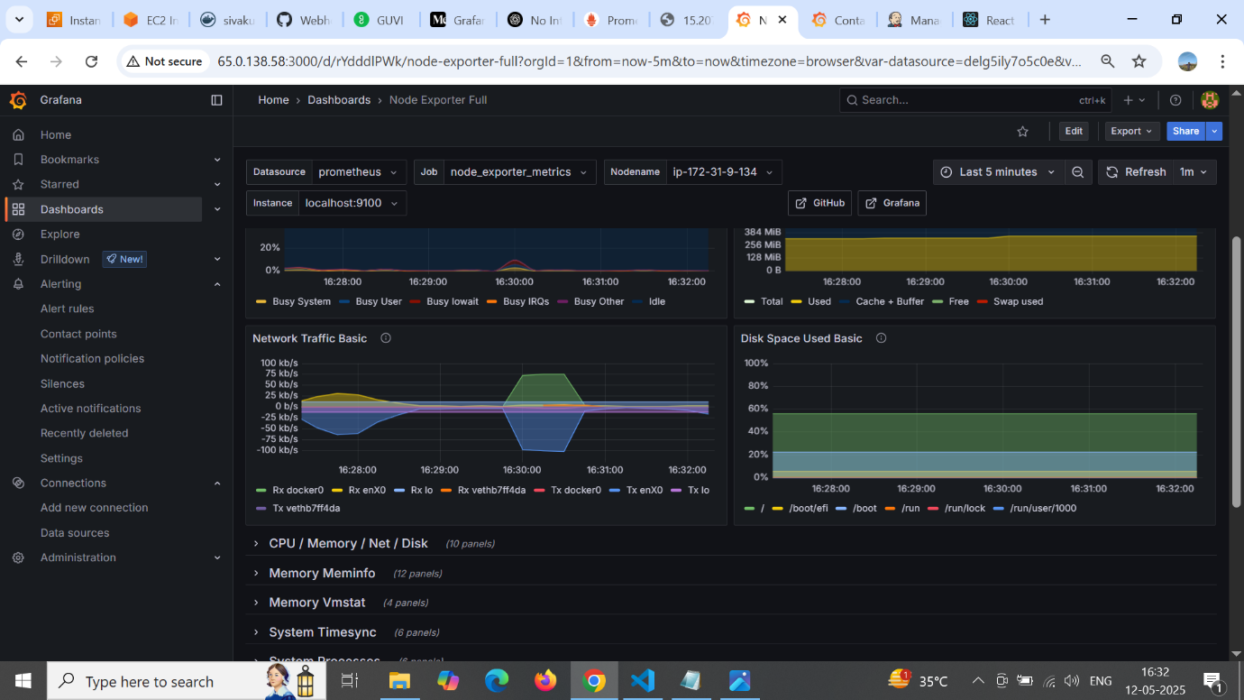

**Prometheus**

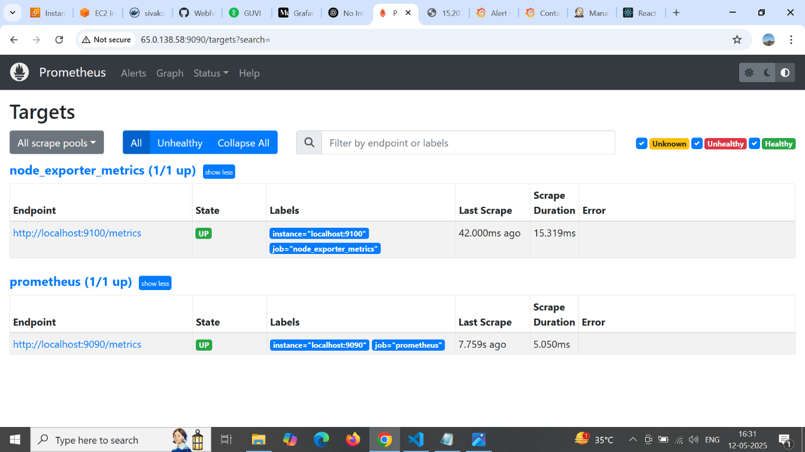

**Jenkins : Docker Credentials**

